Classical Influence in Modern Architecture: The Kenya National Archives
A compelling example of a building constructed after 1900 in the classical architectural style is the Kenya National Archives, located in downtown Nairobi. Completed in 1931 and originally serving as the National Bank of India’s headquarters, this landmark is defined by its neoclassical design, which draws directly from the formulas pioneered by the ancient Greeks over two millennia ago.
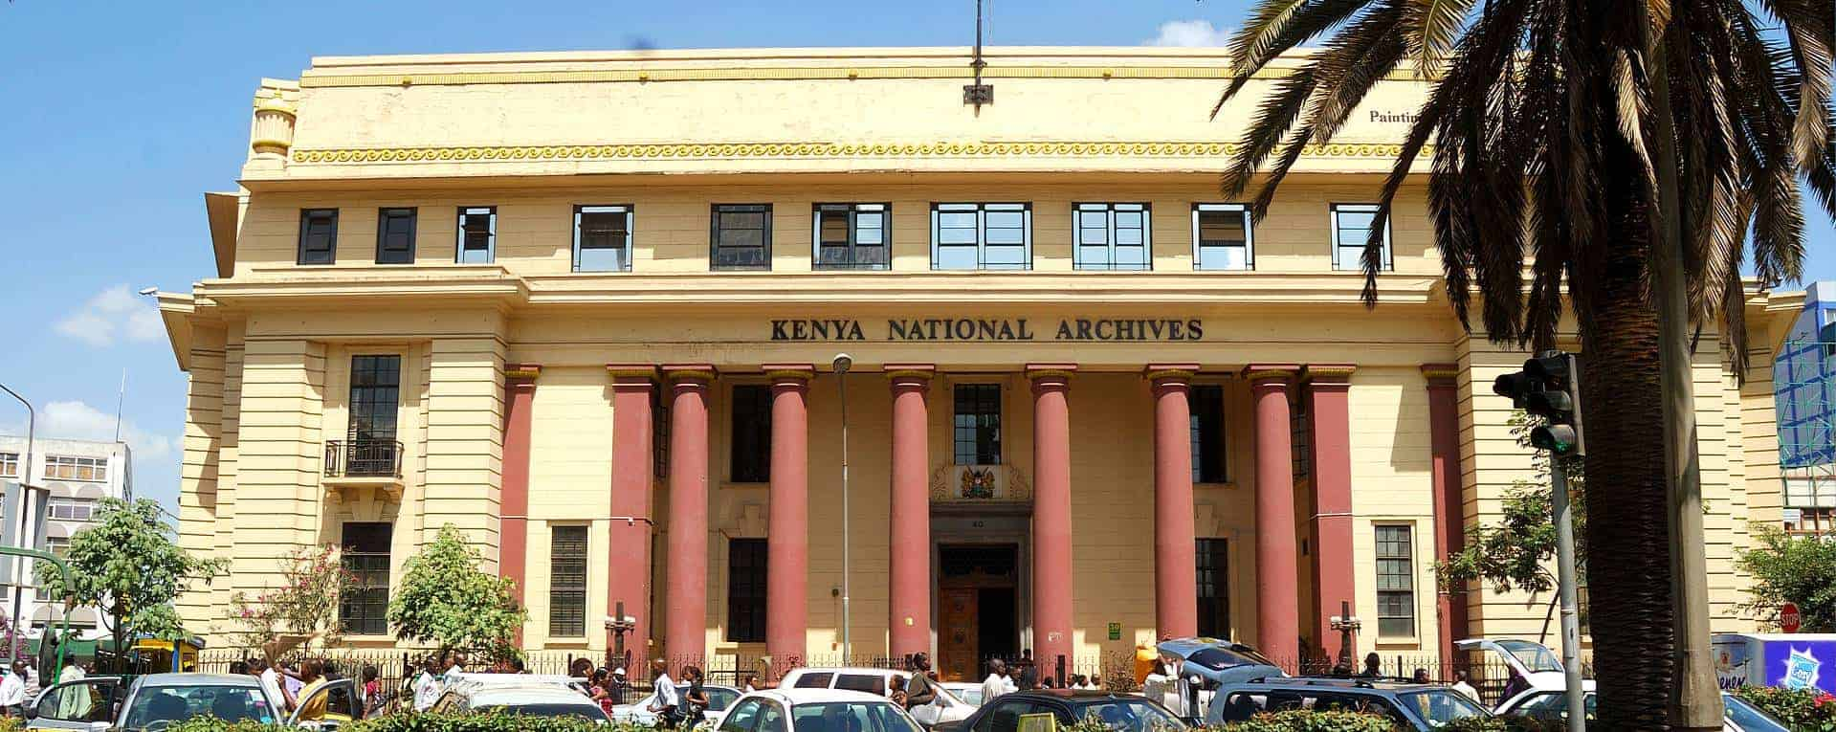

Classical elements and their enduring influence
The classical orders, namely Doric, Ionic, and Corinthian, form the backbone of Western architectural vocabulary. As explained in the video transcript, these styles are instantly recognizable, not only by their decorative capitals but by structural features such as fluted columns and symmetrical façades. The Greeks developed these systems, using post-and-lintel construction, vertical posts supporting horizontal lintels, and enriched them with decorative details that became symbolic building blocks of architecture. The Kenya National Archives manifests these principles through the use of grand, fluted columns, ornate details, and a harmonious, formal façade reminiscent of Greco-Roman temples.

Architectural choice and messaging
Why did the architects choose a classical style for a building in colonial-era Nairobi? The classical style, especially as interpreted through neoclassicism, conveys messages of permanence, stability, and order. These qualities were particularly valued for institutions such as banks and later archives, which are entrusted with safeguarding valuable resources, whether financial or historical. By echoing the grandeur and gravity of ancient architecture, the designers sought to inspire public trust, communicate institutional strength, and align the building with the tradition of Western civic spaces. The classical orders signal authority and endurance; their use suggests the building is a place of significance, worthy of respect, and resistant to the passage of time.

Suitability of classical style for function
The function of the Kenya National Archives aligns closely with the classical style. Like the temples of Greece, which were designed to house sacred artifacts and rituals, the Archives are intended to preserve and display records vital to the nation’s history and identity. The open-plan ground floor, adorned with high ceilings and fluted columns, creates a sense of spaciousness and solemnity appropriate for exhibitions and public gatherings. The original bank vaults, repurposed for archival storage, evoke the strength and security associated with classical construction techniques. The symmetrical design and decorative columns also facilitate navigation and lend dignity to spaces where the public interacts with Kenya’s cultural and historical heritage.
Moreover, the choice of classical architecture for a public archive serves a symbolic function. It shows reverence for the past, not only for the documents housed within, but for the architectural traditions that have shaped civic spaces across cultures and eras. The neoclassical style bridges historical continuity and modern utility, echoing the Greek concern for both beauty and human experience, as discussed in the transcript. The building’s adaptation from a bank to an archive further underscores the flexibility and enduring relevance of classical design; it remains both functional and evocative, capable of supporting varied uses while retaining its symbolic weight.

Conclusion
The Kenya National Archives exemplifies how the formulas of ancient Greek architecture continue to influence modern buildings, serving not only aesthetic purposes but also practical and symbolic ones. By choosing the classical style, the architects communicated messages of authority, endurance, and public trust, while providing an appropriate setting for the preservation and study of history. This enduring legacy of classical architecture is a testament to its power to shape meaning, experience, and the very identity of civic institutions in a changing world.
Webography
AfricanMecca Safaris. (2022, March 1). National Archives tour experience in Nairobi, Kenya. AfricanMecca Safaris - Wildlife Tour & Travel Experts. https://shorturl.at/i7ZeT
Getty Images. (2025). Neo-classical building of the Kenya National Archives, Nairobi, Kenya - stock photo. https://www.gettyimages.ca/detail/photo/neo-classical-building-of-the-kenya-national-royalty-free-image/1323011898

